Assignment 1

Application Development

Abdul Mateen Rahmat - 34833

2018

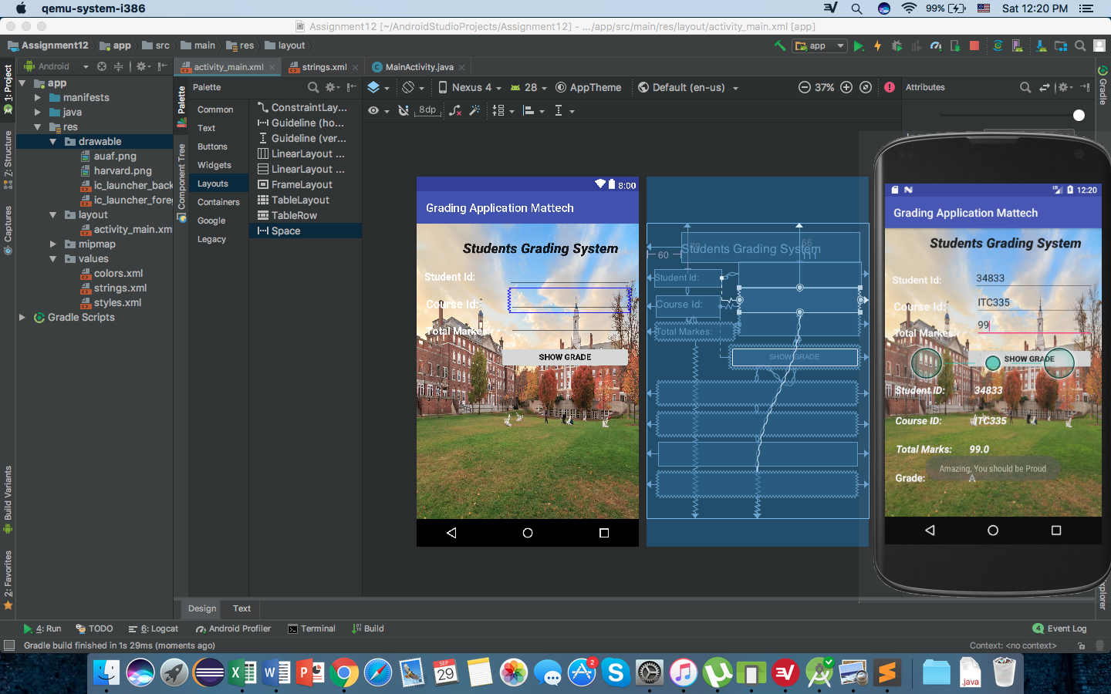

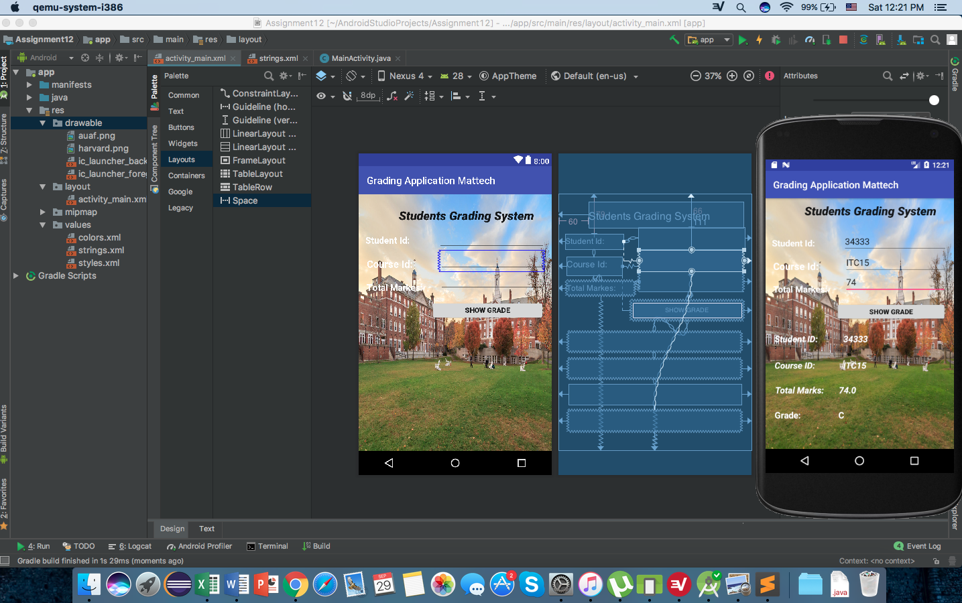

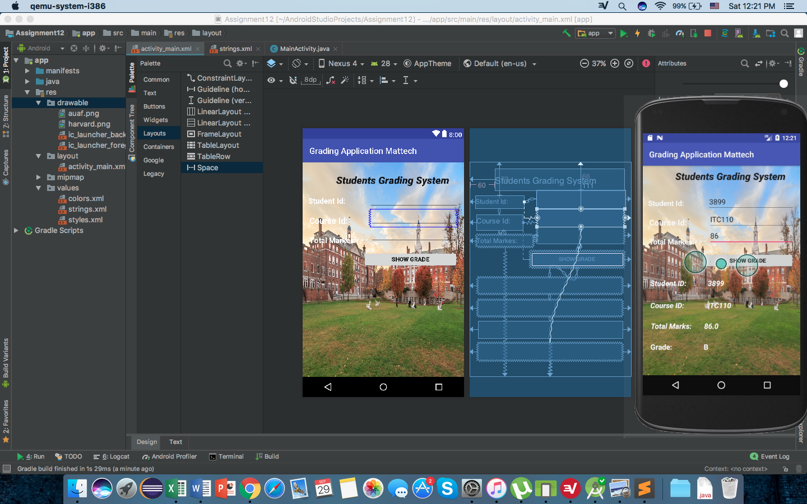

Java Codes:

**package** com.example.mac.assignment1;  
  
**import** android.support.v7.app.AppCompatActivity;  
**import** android.os.Bundle;  
**import** android.view.View;  
**import** android.widget.Button;  
**import** android.widget.TextView;  
**import** android.widget.Toast;  
  
**public class** MainActivity **extends** AppCompatActivity {  
  
 TextView **stid** = **null**;  
 TextView **courseid** = **null**;  
 TextView **mark** = **null**;  
 Button **see** = **null**;  
 TextView **viewname** = **null**;  
 TextView **viewcoid** = **null**;  
 TextView **viewmark** = **null**;  
 TextView **viewgpa** = **null**;  
 String **StudentId**,**ClassId**,**Marks**,**gpa**;  
 **double e**;  
  
 @Override  
  
  
  
 **protected void** onCreate(Bundle savedInstanceState) {  
 **super**.onCreate(savedInstanceState);  
 setContentView(R.layout.***activity_main***);  
 **stid** = findViewById(R.id.***tvname***);  
 **courseid**= findViewById(R.id.***tvid2***);  
 **mark** = findViewById(R.id.***tvmark3***);  
  
  
 **viewname** = findViewById(R.id.***textViewname***);  
 **viewcoid** = findViewById(R.id.***Corsid***);  
 **viewmark** = findViewById(R.id.***Mark1***);  
 **viewgpa** = findViewById(R.id.***total***);  
  
 }  
  
  
  
  
 **public void** button(View view) {  
  
 **StudentId** = **stid**.getText().toString();  
 **int** ID = Integer.*parseInt*(**StudentId**);  
 **viewname**.setText(**"Student ID: \t\t"**+ ID);  
  
 **ClassId** = **courseid**.getText().toString();  
 **viewcoid**.setText(**"Course ID: \t\t"**+ **ClassId**);  
  
 **Marks** = **mark**.getText().toString();  
 **e** = Double.*parseDouble*(**Marks**);  
 **viewmark**.setText(**"Total Marks: \t\t\t"** + **e**);  
  
  
 grading();  
 **viewgpa**.setText(**"Grade: \t\t\t\t\t\t\t\t"**+**gpa**);  
  
 }  
 **public void** grading(){  
  
  
  
 **if** (**e** >= 94 && **e**<=100){  
 **gpa** =**"A"**;  
 Toast.*makeText*(**this**,**"Amazing, You should be Proud"**, Toast.***LENGTH_SHORT***).show();  
 }  
 **else if** (**e** < 94 && **e** >=90) {  
 **gpa** = **"-A"**;  
 Toast.*makeText*(**this**,**"Great Job"**, Toast.***LENGTH_SHORT***).show();  
 }  
 **else if** (**e** < 90 && **e** >=87){  
 **gpa** = **"B+"**;  
 Toast.*makeText*(**this**,**"Excellent"**, Toast.***LENGTH_SHORT***).show();  
 }  
 **else if** (**e** < 87 && **e** >=84){  
 **gpa** = **"B"**;  
 Toast.*makeText*(**this**,**"Well Done"**, Toast.***LENGTH_SHORT***).show();  
 }  
 **else if** (**e** < 84 && **e** >=80){  
 **gpa** = **"B-"**;  
 Toast.*makeText*(**this**,**"Fine, Try Harder"**, Toast.***LENGTH_SHORT***).show();  
 }  
 **else if** (**e** < 80 && **e** >=77){  
 **gpa** = **"C+"**;  
 Toast.*makeText*(**this**,**"You could have done better"**, Toast.***LENGTH_SHORT***).show();  
 }  
 **else if** (**e** < 77 && **e** >=74){  
 **gpa** = **"C"**;  
 Toast.*makeText*(**this**,**"dont be a retard and work hard"**, Toast.***LENGTH_SHORT***).show();  
 }  
 **else if** (**e** < 74 && **e** >=70){  
 **gpa** = **"C-"**;  
 Toast.*makeText*(**this**,**"Come on, STUDY"**, Toast.***LENGTH_SHORT***).show();  
 }  
 **else if** (**e** < 70 && **e** >=67){  
 **gpa** = **"D+"**;  
 Toast.*makeText*(**this**,**"SERIOUSLY?"**, Toast.***LENGTH_SHORT***).show();  
 }  
 **else if** (**e** < 67 && **e** >=64){  
 **gpa** = **"D"**;  
 Toast.*makeText*(**this**,**"Its Such a Shame"**, Toast.***LENGTH_SHORT***).show();  
 }  
 **else if** (**e** < 64 && **e** >=60){  
 **gpa** = **"D-"**;  
 Toast.*makeText*(**this**,**"I am sorry for you."**, Toast.***LENGTH_SHORT***).show();  
 }  
 **else if** (**e**<60){  
 **gpa** = **"F"**;  
 Toast.*makeText*(**this**,**"You loser."**, Toast.***LENGTH_SHORT***).show();  
 }  
 **else if** (**e**>100){  
 **gpa** = **"Write Valid Marks"**;  
 Toast.*makeText*(**this**,**"Try to Write valid Marks"**, Toast.***LENGTH_SHORT***).show();  
 }  
  
  
  
  
 }  
}

XLM Codes:

*<?***xml version="1.0" encoding="utf-8"***?>*<**android.support.constraint.ConstraintLayout xmlns:android="http://schemas.android.com/apk/res/android"  
 xmlns:app="http://schemas.android.com/apk/res-auto"  
 xmlns:tools="http://schemas.android.com/tools"  
 android:layout_width="match_parent"  
 android:layout_height="match_parent"  
 tools:context=".MainActivity"  
 tools:layout_editor_absoluteY="81dp"  
 android:background="@drawable/harvard"**>  
  
 <**EditText  
 android:id="@+id/tvname"  
 android:layout_width="212dp"  
 android:layout_height="45dp"  
 android:layout_marginEnd="16dp"  
 android:layout_marginTop="66dp"  
 android:ems="10"  
 android:inputType="textPersonName"  
 android:visibility="visible"  
 app:layout_constraintBottom_toTopOf="@+id/tvid2"  
 app:layout_constraintEnd_toEndOf="parent"  
 app:layout_constraintStart_toEndOf="@+id/textView3"  
 app:layout_constraintTop_toTopOf="parent"** />  
  
 <**EditText  
 android:id="@+id/tvmark3"  
 android:layout_width="208dp"  
 android:layout_height="0dp"  
 android:layout_marginBottom="18dp"  
 android:layout_marginEnd="15dp"  
 android:ems="10"  
 android:inputType="textPersonName"  
 android:visibility="visible"  
 app:layout_constraintBottom_toTopOf="@+id/but4"  
 app:layout_constraintEnd_toEndOf="parent"  
 app:layout_constraintStart_toEndOf="@+id/textView6"  
 app:layout_constraintTop_toBottomOf="@+id/tvid2"** />  
  
 <**EditText  
 android:id="@+id/tvid2"  
 android:layout_width="209dp"  
 android:layout_height="0dp"  
 android:layout_marginBottom="276dp"  
 android:layout_marginEnd="14dp"  
 android:layout_marginTop="111dp"  
 android:ems="10"  
 android:inputType="textCapCharacters"  
 android:visibility="visible"  
 app:layout_constraintBottom_toTopOf="@+id/total"  
 app:layout_constraintEnd_toEndOf="parent"  
 app:layout_constraintHorizontal_bias="1.0"  
 app:layout_constraintStart_toEndOf="@+id/textView3"  
 app:layout_constraintTop_toTopOf="parent"** />  
  
 <**TextView  
 android:id="@+id/textView3"  
 android:layout_width="116dp"  
 android:layout_height="31dp"  
 android:layout_marginBottom="15dp"  
 android:layout_marginEnd="32dp"  
 android:layout_marginStart="16dp"  
 android:layout_marginTop="79dp"  
 android:text="Student Id:"  
 android:textColor="?attr/colorBackgroundFloating"  
 android:textSize="18sp"  
 android:textStyle="bold"  
 android:visibility="visible"  
 app:layout_constraintBottom_toTopOf="@+id/textView2"  
 app:layout_constraintEnd_toStartOf="@+id/tvname"  
 app:layout_constraintStart_toStartOf="parent"  
 app:layout_constraintTop_toTopOf="parent"** />  
  
 <**TextView  
 android:id="@+id/textView2"  
 android:layout_width="111dp"  
 android:layout_height="38dp"  
 android:layout_marginBottom="10dp"  
 android:layout_marginEnd="18dp"  
 android:layout_marginStart="16dp"  
 android:text="Course Id:"  
 android:textColor="?attr/colorBackgroundFloating"  
 android:textSize="20sp"  
 android:textStyle="bold"  
 android:visibility="visible"  
 app:layout_constraintBottom_toTopOf="@+id/textView6"  
 app:layout_constraintEnd_toStartOf="@+id/tvmark3"  
 app:layout_constraintHorizontal_bias="0.0"  
 app:layout_constraintStart_toStartOf="parent"  
 app:layout_constraintTop_toBottomOf="@+id/textView3"** />  
  
 <**TextView  
 android:id="@+id/textView6"  
 android:layout_width="0dp"  
 android:layout_height="0dp"  
 android:layout_marginBottom="308dp"  
 android:layout_marginEnd="9dp"  
 android:layout_marginStart="16dp"  
 android:text="Total Markes:"  
 android:textColor="?attr/colorBackgroundFloating"  
 android:textSize="18sp"  
 android:textStyle="bold"  
 android:visibility="visible"  
 app:layout_constraintBottom_toBottomOf="parent"  
 app:layout_constraintEnd_toStartOf="@+id/tvmark3"  
 app:layout_constraintStart_toStartOf="parent"  
 app:layout_constraintTop_toBottomOf="@+id/textView2"** />  
  
 <**Button  
 android:id="@+id/but4"  
 android:layout_width="0dp"  
 android:layout_height="0dp"  
 android:layout_marginBottom="23dp"  
 android:layout_marginEnd="15dp"  
 android:layout_marginStart="17dp"  
 android:onClick="button"  
 android:text="Show Grade"  
 android:textStyle="bold"  
 android:visibility="visible"  
 app:layout_constraintBottom_toTopOf="@+id/textViewname"  
 app:layout_constraintEnd_toEndOf="parent"  
 app:layout_constraintHorizontal_bias="0.0"  
 app:layout_constraintStart_toEndOf="@+id/textView2"  
 app:layout_constraintTop_toBottomOf="@+id/tvmark3"** />  
  
 <**TextView  
 android:id="@+id/textViewname"  
 android:layout_width="0dp"  
 android:layout_height="0dp"  
 android:layout_marginBottom="14dp"  
 android:layout_marginEnd="19dp"  
 android:layout_marginStart="19dp"  
 android:textColor="?attr/colorBackgroundFloating"  
 android:textSize="18sp"  
 android:textStyle="bold|italic"  
 android:visibility="visible"  
 app:layout_constraintBottom_toTopOf="@+id/Corsid"  
 app:layout_constraintEnd_toEndOf="parent"  
 app:layout_constraintStart_toStartOf="parent"  
 app:layout_constraintTop_toBottomOf="@+id/but4"** />  
  
 <**TextView  
 android:id="@+id/Corsid"  
 android:layout_width="0dp"  
 android:layout_height="0dp"  
 android:layout_marginBottom="11dp"  
 android:layout_marginEnd="19dp"  
 android:layout_marginStart="19dp"  
 android:textColor="@android:color/background_light"  
 android:textSize="18sp"  
 android:textStyle="bold|italic"  
 android:visibility="visible"  
 app:layout_constraintBottom_toTopOf="@+id/Mark1"  
 app:layout_constraintEnd_toEndOf="parent"  
 app:layout_constraintStart_toStartOf="parent"  
 app:layout_constraintTop_toBottomOf="@+id/textViewname"** />  
  
 <**TextView  
 android:id="@+id/Mark1"  
 android:layout_width="344dp"  
 android:layout_height="42dp"  
 android:layout_marginBottom="91dp"  
 android:layout_marginEnd="23dp"  
 android:layout_marginStart="23dp"  
 android:textColor="?attr/colorBackgroundFloating"  
 android:textSize="18sp"  
 android:textStyle="bold|italic"  
 android:visibility="visible"  
 app:layout_constraintBottom_toBottomOf="parent"  
 app:layout_constraintEnd_toEndOf="parent"  
 app:layout_constraintStart_toStartOf="parent"  
 app:layout_constraintTop_toBottomOf="@+id/Corsid"** />  
  
 <**TextView  
 android:id="@+id/total"  
 android:layout_width="0dp"  
 android:layout_height="0dp"  
 android:layout_marginBottom="39dp"  
 android:layout_marginEnd="19dp"  
 android:layout_marginStart="19dp"  
 android:textColor="@android:color/background_light"  
 android:textSize="18sp"  
 android:textStyle="bold"  
 app:layout_constraintBottom_toBottomOf="parent"  
 app:layout_constraintEnd_toEndOf="parent"  
 app:layout_constraintStart_toStartOf="parent"  
 app:layout_constraintTop_toBottomOf="@+id/tvid2"** />  
  
 <**TextView  
 android:id="@+id/textView5"  
 android:layout_width="308dp"  
 android:layout_height="52dp"  
 android:layout_marginStart="60dp"  
 android:gravity="center"  
 android:text="Students Grading System"  
 android:textAllCaps="false"  
 android:textAppearance="@style/TextAppearance.AppCompat.Title"  
 android:textSize="24sp"  
 android:textStyle="bold|italic"  
 android:visibility="visible"  
 app:layout_constraintStart_toStartOf="parent"  
 tools:layout_editor_absoluteY="16dp"** />  
  
 <**android.support.constraint.Group  
 android:id="@+id/group"  
 android:layout_width="wrap_content"  
 android:layout_height="wrap_content"** />  
  
</**android.support.constraint.ConstraintLayout**>